KOI DISEASE MONITORING SYSTEM

A Capstone Project

Presented to the Faculty of

Iloilo State College of Fisheries

Main Poblacion Barotac Nuevo

Barotac Nuevo, Iloilo

In Partial Fulfilment

of the

Requirements of the Degree

Bachelor of Science in Information Technology

By:

Names nyo

**CHAPTER 1**

**Introduction**

*Overview of the current state of technology*

Have you ever caught up about an aquatic animal that is often associated with strength of character, perseverance, accomplishment and courage? The said aquatic animal also symbolizes good fortune, wealth, success, prosperity and ambition. Yes, it’s the Koi fish also known with its scientific name *“cyprinus carpio’’*. Koi fishes’ legendary history and natural endurance also led them being associated with longevity of human existence.

Koi fishes are domesticated and tamed version of a common carp fish. Koi fishes are renowned due of the combination of dynamic array of colors that have been shaped and created via strict selective breeding. There are over twenty (20) different varieties of Koi fishes that varies in color, patterns and types of scales. This unique chromatic spectrum of colors makes them one of kind and unique aquatic animal. Koi fish originates from Eastern Asia and usually lives in fresh waters. Due to the appreciations of its beauty and increased popularity in the past century, Koi fishes can commonly be found on ponds or residential fish tanks around the planet. Since Koi fish is abundant and kept in private aquacultures, it is not on the list of endangered species. Having this on our backyard fish pond or on our fish tanks brings us joy and most of us believes that it will give us a tremendously good fortune and prosperity. Therefore, we certainly need to take good care of the said fish. We should also recognize all the information on how to monitor them especially when they are in discomfort and needs immediate assistance.

Based on the thorough research and investigation of the researchers on Bureau of Fisheries and Aquatic Resources (BFAR) and fish’s lovers concerning Koi’s aquaculture, the following problems where identified:

1. Few precise and detailed information relative to the said aquaculture.
2. Some enthusiasts don’t know how to properly feed the said fish properly that sometimes cause them to be unwell or terminally ill;
3. Some people don’t know the signs and symptoms when the Koi are sick;
4. Koi owners don’t know how to give cure to the diseases of their aquatic pets;
5. No known device that can check the quality of water that is suited for Koi;
6. It’s extremely confusing to tell if the pond or fish tank is over populated or not;

Setting up a pond or fish tank full of Koi gives us the benefit for our visual organs and gives us feel the pleasure having just it. But are we aware of the consequences? Could we know if the source of our joy might be experiencing distress? Do we have an option to check them from time to time? Will we be with them if they need aid? Koi is just same as humans; they can also experience trouble especially diseases sometimes from unwell to terminally ill. The researchers proposed to develop a Koi disease monitoring app that give concepts and a method on how to monitor and check the status of the Koi fish and to methodically familiarize their nature. The researchers also provide ideas on how to distinguish if the said koi might be experiencing sickness or might be carrying some diseases.

**Statement of Objectives**

This study aims to design and develop a website, mobile and hardware-based system that can be used as a guide on how to manage Koi fishes.

Specifically, this study aims to:

1. develop a Koi disease monitoring system;
2. develop a platform that guides owners regarding the major diseases that Koi experience and its cure;
3. offer an information on proper ways of feeding the Koi;
4. provide data on the ideal number of Koi that can be handled per given area.
5. integrate hardware that can sense acidity and temperature;
6. evaluate and test developed system using ISO 25010:2011 software engineering standard in terms of product quality and quality in use.

**Conceptual Framework**

The selection of adequate concepts and efficient tools is imperative in the proposal of a Koi Disease Monitoring system. Thus, the following are the essential concepts that contribute to the development and implementation of Koi Disease Monitoring System.

The system under development from this study could be used on any type of browser except Internet Explorer (IE) while any mobile device that supports .apk or .ipa file extensions can suffice to run the mobile application. The hardware that was used in this system is a raspberry pi microcomputer with pH and temperature sensing device. The said system under development use the following frameworks: Angular for website’s front end; React Native for the mobile app; Python Programming Language for the hardware side; and Firebase for the storage, authentication and database.

Before the implementation, this system will be tested and evaluated by some experts and future users.

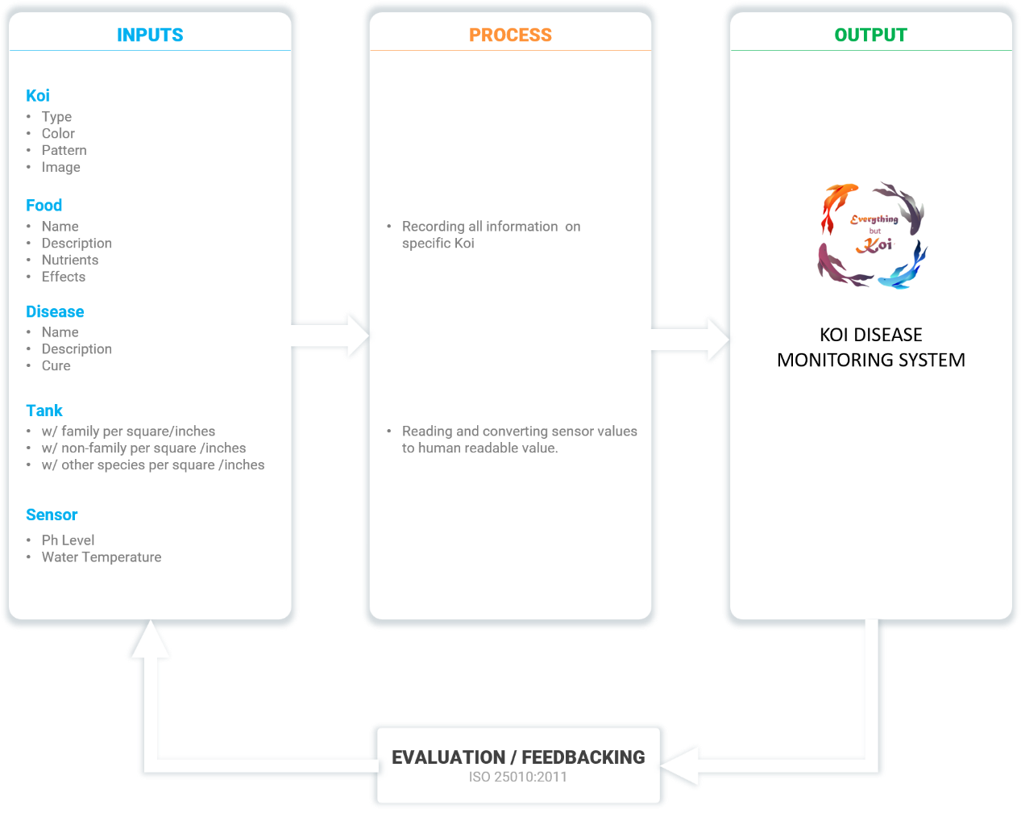

Figure 1. Conceptual Framework

This study is to develop a Koi Disease Monitoring System. Figure 1 shows how the Development started; the researcher gathered all necessary information linked for Koi monitoring. The researchers interviewed fish lovers, Bureau of Fisheries and Aquatic Resources (BFAR) and selective Koi enthusiast about the rising problem in the domestication of Koi Fish. All the information gathered are integrated and processed to perform all functions of the Koi Disease Monitoring system. The said system is dubbed as “Everything but Koi”.

*Definition of terms*

**Koi.** This are colored varieties of the Amur carp that are kept for decorative purposes in outdoor koi ponds or water gardens. ([www.oxfordlearnersdictionaries.com](http://www.oxfordlearnersdictionaries.com)/koi, 2020)

As used in this study, the term refers to the kind of carp fish that brings good luck to the owner.

**Disease.** Itis a particular abnormal condition that negatively affects the structure or function of all or part of an organism, and that is not due to any immediate external injury. ([www.oxfordlearnersdictionaries.com](http://www.oxfordlearnersdictionaries.com)/disease, 2018)

As used in this study, the term refers to the condition that Koi experience that causes them to be sick.

**Monitoring.** It is toobserve and check the progress or quality of (something) over a period of time; keep under systematic review. ([www.oxfordlearnersdictionaries.com](http://www.oxfordlearnersdictionaries.com)/aquaculture, 2020)

As used in this study, the term refers to checking of the koi fishes’ overall status from time to time.

**Fish Tanks.** A large glass container in which fish and other water creatures and plants are kept. ([www.oxfordlearnersdictionaries.com](http://www.oxfordlearnersdictionaries.com)/us/definition/english/aquarium, 2020)

As used in this study, the term refers to containers where Koi fishes are stored.

**Sensors.** A device that can react to light, heat, pressure, etc. in order to make a machine do something or show something

As used in this study, the term refers to devices that sense temperature and acidity of water.

**Aquaculture.** It is the farming of fish, crustaceans, mollusks, aquatic plants, algae, and other organisms. It involves cultivating freshwater and saltwater populations under controlled conditions, and can be contrasted with commercial fishing, which is the harvesting of wild fish.

([www.oxfordlearnersdictionaries.com](http://www.oxfordlearnersdictionaries.com)/aquaculture, 2019)

As used in this study, the term refers to the overall ways of Koi farming.

**Significance of the Study**

The result of the study may benefit the following group of people and entity:

Koi Owners. The study and the system will be beneficial for they can monitor their fish tanks even if they’re away.

Koi Enthusiast. This study will be beneficial to them because they can get additional knowledge on how to take good care of their Kois.

BFAR. This study will be a great help to them because it can help them gain more information on how to manage Koi fish raising industry.

**Scope and Limitations of the Study**

The study aimed to design and develop a system that can be used by anyone who has interest in Koi raising or those who were raising Koi already. The system is limited to the people who are connected to the internet and its service that includes a real-time monitoring of Koi ponds or aquarium with the use of sensing device that detects the acidity and temperature of water. Offline users could contact Bureau of Fisheries and Aquatic Resources (BFAR) phone numbers that is shown on the main page for immediate assistance or guidance.

The system provides all guides and information across different species and types of Koi Fish. The said system is compatible to almost all mobile devices that supports .apk or .ipa file extensions can suffice to run the mobile application.

The Koi Disease Monitoring System will be available in the Play Store for Android users and App Store for iPhone users. No account creation required.

The researchers work directly with the Bureau of Fisheries and Aquatic Resources (BFAR) for the proper terms and guidelines of the application. The application will be using the International Standards Organization (ISO) software engineering quality standard in terms of product quality and quality in use. The application will be evaluated by BFAR, five (5) IT experts, and five (5) Koi enthusiast that will be the future users of the app.

Chapter 2

**Review of Related Literature and Studies**

This chapter presents the review of local and foreign literature and studies related to the presented study.

**Monitoring Information System**

Monitoring provides information on a continuous basis to inform programme managers about planned and actual developments. Monitoring involves collecting and analyzing data to verify that resources are used as intended, that activities are implemented according to plan, that the expected products and services are delivered and that intended beneficiaries are reached. Effective monitoring should be central to all projects. It helps to detect problems, take corrective actions and lay the groundwork to produce evidence about what works in creating decent jobs for youth. That being said, monitoring systems come with a cost.

Monitoring also provides the foundation to evaluate an intervention. In fact, a good evaluation is hard to conduct without good monitoring information from actual implementation. If no reliable information about the progress and quality of implementation is available, then any evaluation undertaken will run the risk of misinterpreting the reasons for the success or failure of the project. (International Labour Organization, 2017).

The fundamental principle of a Monitoring system is to allow users to capture data, process and disseminate information in a systematic way. Monitoring system enables us to measure trends of various indicators based on the data collected in the field. A monitoring system is vital in supporting post disaster relief and recovery. Systematic assessment and review at one point in time of post disaster activities helps

us monitor the progress and support to evaluate the sustainable impact on affected community. This chapter intends to facilitate the understanding of the basic ideas behind monitoring and evaluation exercise (Fukuka UN - Habitat, 2005).

**Disease-Specific Monitoring Systems**

Disease-specific surveillance systems are used to monitor the prevalence and characteristics of different microbes. The surveillance of these diseases is described in manuals containing information on the monitoring methods used as well as definitions and instructions for the parties involved in this work.

Data collected through surveillance systems can be used to prevent and control infectious diseases and to develop and support the vaccination programme.

While separate surveillance systems only exist for a few diseases, many others are monitored using the National Infectious Diseases Register and laboratory monitoring based on samples sent to the microbial strain collection (Suomeksi and På svenska, 2020).

**Fish Management Area**

A Fish Management Area (FMA) is a pond, lake or other body of water established for the management of freshwater fish as a cooperative effort with the local county. The FWC's Division of Freshwater Fisheries manages about 80 water bodies throughout the state that are designated as Fish Management Areas. Examples include most community-based fishing lakes and Commission-managed impoundments. In many cases, these lakes are stocked with channel catfish, large mouth bass and sunshine bass. Automatic fish feeders and fish attractors concentrate sport fish for bank anglers(Florida Fish and Wildlife Conservation Commission).

Fishery management institutions have some limited sphere of influence. For example, a fishery management plan may manage a state or provincial fishery, a plan may deal with a region's fishery or fisheries, have national scope, and so forth. Moreover, there are many institutional arrangements that have jurisdiction beyond national boundaries, for example, the Northwest Atlantic Fishery Organization (NAFO), or the International Commission for the Conservation of Tuna (ICCAT).

Fishery management is directed toward maximizing the benefits of the production unit (fish stock) that is being managed. Since stock boundaries may transcend national boundaries, many new geopolitical complications arise. Thus it is important to design an institution which promotes compromise among diverse human interests and values. This can be difficult not only conceptually, but practically as well if different management bodies in different countries use different approaches, timing, systems, etc.Since ultimately the goal is to manage a stock appropriately, it is possible to delegate some management elements to a more local scale, while insuring that the collective impact on the fishery resource is sustainable (T.P. Smith, M.P. Sissenwine, in Encyclopedia of Ocean Sciences (Second Edition), 2001).

**pH Measurement System**

A very important measurement in many liquid chemical processes (industrial, pharmaceutical, manufacturing, food production, etc.) is that of pH: the measurement of hydrogen ion concentration in a liquid solution. A solution with a low pH value is called an “acid,” while one with a high pH is called a “caustic.” The common pH scale extends from 0 (strong acid) to 14 (strong caustic), with 7 in the middle representing pure water (neutral).

pH is defined as follows: the lower-case letter “p” in pH stands for the negative common (base ten) logarithm, while the upper-case letter “H” stands for the element hydrogen. Thus, pH is a logarithmic measurement of the number of moles of hydrogen ions (H+) per liter of solution. Incidentally, the “p” prefix is also used with other types of chemical measurements where a logarithmic scale is desired, pCO2 (Carbon Dioxide) and pO2 (Oxygen) being two such examples. The logarithmic pH scale works like this: a solution with 10-12 moles of H+ ions per liter has a pH of 12; a solution with 10-3 moles of H+ ions per liter has a pH of 3. While very uncommon, there is such a thing as an acid with a pH measurement below 0 and a caustic with a pH above 14. Such solutions, understandably, are quite concentrated and extremely reactive (EA Elektro-Automatik, 2020).

**Temperature Management System**

Temperature measurement in today’s industrial environment encompasses a wide variety of needs and applications. To meet this wide array of needs the process controls industry has developed a large number of sensors and devices to handle this demand. In this experiment you will have an opportunity to understand the concepts and uses of many of the common transducers, and actually run an experiment using a selection of these devices. Temperature is a very critical and widely measured variable for most mechanical engineers. Many processes must have either a monitored or controlled temperature. This can range from the simple monitoring of the water temperature of an engine or load device, or as complex as the temperature of a weld in a laser welding application. More difficult measurements such as the temperature of smoke stack gas from a power generating station or blast furnace or the exhaust gas of a rocket may be need to be monitored. Much more common are the temperatures of fluids in processes or process support applications, or the temperature of solid objects such as metal plates, bearings and shafts in a piece of machinery (web.mst.edu, 2006).

These types of temperature sensor vary from simple ON/OFF thermostatic devices which control a domestic hot water heating system to highly sensitive semiconductor types that can control complex process control furnace plants.

We remember from our school science classes that the movement of molecules and atoms produces heat (kinetic energy) and the greater the movement, the more heat that is generated. Temperature Sensors measure the amount of heat energy or even coldness that is generated by an object or system, allowing us to “sense” or detect any physical change to that temperature producing either an analogue or digital output. There are many different types of Temperature Sensor available and all have different characteristics depending upon their actual application (ElectronicsTutorials,2014).

**Web Content Management System**

A subsection of Content Management is Web Content Management or WCM. A WCMS is a program that helps in maintaining, controlling, changing, and reassembling the content on a webpage. Content on webpages must be managed like all other content. Web Content Management (WCM) is used to create, manage, store, and display content on webpages. Web Content Management, or WCM, is a lot like content management in that it manages the integrity, revisions, and lifecycle of information – except it specializes in content that is specifically destined for the web.

A Web Content Management System (WCMS) is a program that helps in maintaining, controlling, changing, and reassembling the content on a web page. Content is mostly kept in a database and assembled using a flexible language like XML or .Net. The user interacts with the system at the front through a normal web browser. From there, the webpages can be edited while maintaining control on parts of the layout (aiim.org, 2020).

**Raspberry Pi**

The Raspberry Pi is a low cost, credit-card sized computer that plugs into a computer monitor or TV, and uses a standard keyboard and mouse. It is a capable little device that enables people of all ages to explore computing, and to learn how to program in languages like Scratch and Python. It’s capable of doing everything you’d expect a desktop computer to do, from browsing the internet and playing high-definition video, to making spreadsheets, word-processing, and playing games.

What’s more, the Raspberry Pi has the ability to interact with the outside world, and has been used in a wide array of digital maker projects, from music machines and parent detectors to weather stations and tweeting birdhouses with infra-red cameras. We want to see the Raspberry Pi being used by kids all over the world to learn to program and understand how computers work (raspberrypi.org,2021).

**Related Studies**

“Fisheries Management Systems”, DTU Aqua’s research into fisheries management develops methods, models and tools for estimating and evaluating the effects of management measures and regulations of fisheries. The results are used for advising national authorities and the EU. The purpose of the evaluation is to optimize sustainable fishing and to minimize the impact of fishing on the ecosystem, including reducing fish discards. DTU Aqua develops holistic models and tools which can contribute to increase the efficiency of fisheries management. The ecosystem and fisheries management models can vary from simple cases to complex issues involving several fish stocks, the affected ecosystem and several fishing fleets and are geographical and seasonal explicit. In addition, some models can link biological, climatic and socioeconomic conditions, to name but a few. Our work involves linking ecosystem simulation models or multi-species models with fisheries bio-economic simulation models, enabling us to compare different scenarios and options for fisheries management. Furthermore we link to other marine management within transport, energy, aquaculture and recreational use of the sea (Karin Stubgaar, 2020).

“Temperature Control System”,based on STC8952 single chip microcomputer is designed, which can store relevant temperature data in real time and record the current time. The system can be used as the core of the system control, and the object SET-300 temperature measurement and control instrument provided by the laboratory is acquired through the DS1820 temperature sensor. The system can output the PWM wave form according to the PID algorithm, output the PWM waveform, turn on and turn off the heating power supply automatically according to the PID algorithm, so that the temperature value in the control instrument can be stabilized within the set range (Bi-Geng Zheng, 2018).

“Embedded Instrumentation Based Soil pH Measurement System”, Soil pH is a measure of hydronium ion (more commonly the H+) activity in the soil solution. Activity is similar to concentration in non-salt-affected soils. Soil pH influences many facets of crop production and soil chemistry, including availabilities of nutrients and toxic substances, activities and nature of microbial populations, and activities of certain pesticides. Soil pH is defined as the negative logarithm (base 10) of the H+

activity (moles per liter) in the soil solution. As the activity of H+ in the soil solution increases, the soil pH value decreases. Soils with pH values below pH 7 are referred to as "acid" and those with pH values above pH 7 as "alkaline"; soils at pH 7 are referred to as "neutral." Hence in present study an attempt is made to implement Embedded based Soil pH meter.

**Local Related Studies**

Calvo, et al (2016) conducted a study on the “Automated Assessment of Subject and Grading Information Kiosk”. The system was evaluated by two (2) staff members from the Registrar’s Office and thirteen (13) randomly selected student. The evaluation data were analyzed using the mean. The result showed that the system was highly usable, highly functional and highly efficient because it requires less effort to manage, printing of records is easier and the system requires less time in processing and it provides performance based on resources used.

A project study of Gumban, et al (2016) entitled “Student Account Notification and Inquiry System Using Short Messaging Services” found out that the system was highly functional, highly efficient, and highly usable as evaluated by thirty-four (34) purposely selected students and one (1) cashier.

Bagsain, et al (2016) made a paper on the “Inventory System with Decision Support System”, using the five (5) administrative staff and supply office personnel and five (5) faculty members. They found out that the system was highly functional, highly usable and highly efficient.

The study “Automated Paymeny System” conducted by Obcional, et al (2016), utilizing seventy-three (73) respondents found out that the system is highly usable, highly functional, and highly efficient. Furthermore, the system was concluded very beneficial on the evaluators feedback if it is implemented in a university.

**Synthesis**

The study of Duk-jin (2006) has the same controlling device, either a laptop or PC (Personal Computer). In this study, any device that has network connection was capable of controlling the system as long as it has a browser present within the device controller. The Study of Arora (2013), GSM Technology is used. Controlling appliances is done by sending SMS to the system. However, compared to the reaction time of physically connected wires to the GSM technology, the networking technology used by the researchers would perform faster than GSM technology because it is physically connected. The study of Gretarsson (2014) is used for industrial purposes, especially in fishing industry where conveyor belts are used to minimize human labor. The researcher’s study was intended for use of home owners, specifically with internet connections, which the goal of the system was to control the framework using network connection.

The study of Karhu (2014) explains the improvements that can be integrated by control system to mechanical and hydraulic components applicable in commercial future machinery. The researcher’s study was intended only for the home owners and the satisfaction it can give to the users without the aid of the hydraulic or mechanical components.

**Chapter 3**

**Methodology**

This chapter covers the project description, project design, project development, the requirement analysis, project evaluation, the data gathering instrument, respondents of the study, data processing and statistical tools.

**Project Description** The operation starts with any personal computer, laptop or any other devices which has a browser and network connection that will access the website of the system. If the user successfully accesses the site, he/she will be able to manage the monitoring system. After successfully accessing the site, he/she will be able to manage the koi by adding it, add its food, current disease and to which container it must be added. The user can also view the koi’s food, disease, and container status. There is also a water quality check for the user to view.

In managing the system, all the user needs to have is a Personal Computer, Laptop or any devices that can connect to the network and has a browser to navigate the system.

If the user is offline due to electricity problem, then they can also contact the Bureau of Fisheries and Aquatic Resources (BFAR) phone numbers that are shown on the main page for immediate assistance or guidance. The system provides all guides and information across different species and types of Koi Fish.

**SYSTEM DEVELOPMENT LIFE CYCLE**

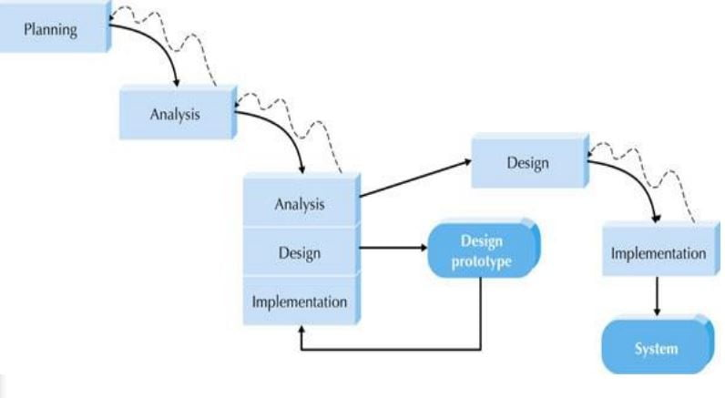

**Figure 2. A Throwaway Model Methodology**

The koi disease monitoring system starts with listing all the possible requirements such as type of koi details, disease details, food details, and container details. After all the gathering of requirements, the researchers started designing on how the program should look like based on its functionality. When designing was done, they checked other matters that should be necessarily added to the system. If the addition of other requirements is not completed, the researchers repeated the process until the system was functional and ready.

**Requirement Analysis**

The succeeding methods included the development of koi disease monitoring system. Information is provided to show the association of work and function of the proposed system. UML or Unified Modeling Language was used by researchers to provide the graphical model of how and what the system does. The researchers created different diagrams such as Activity Diagram, Class Diagram, Block Diagram and Use Case Diagram.

The following figures illustrated the flow of the system in the requirement analysis.

In the preceding diagrams, the administrator must login in into the system through username and password. If the username and password is incorrect, it will return an error dialog box. If the username and password is correct, the administrator can Add Koi, View Koi and Check Water Quality. The administrator can also update the system if he/she wants to.

*Activity Diagram*

Logout

Add Food

Add Disease

Add Container

Login

**Figure 3***. Administrator Activity Diagram for Dashboard*

Figure 3 shows the administrator activity diagram for add koi. The administrator can add koi’s food, current disease and container.

Confirmation

Add Koi

Add Food

Add Disease

Add Container

Login

**Figure 4.** *Administrator Activity Diagram for Add Koi*

Figure 4 shows the administrator activity diagram for add koi. The administrator can add koi’s food, current disease and container.

Login

View Food

View Disease

View Container

Confirmation

View Koi

**Figure 5.** *Administrator Activity Diagram for View Koi*

Figure 5 shows the administrator activity diagram for view koi. The administrator can view kois food, current disease and container.

Check Water Quality

Login

**Figure 6.** *Administrator Activity Diagram for Checking of Water Quality*

Figure 6 shows the administrator activity diagram for checking the tank water quality. The administrator can monitor the tank water quality.

*Use Case Diagram*

Koi Disease Monitoring System

ADMIN

<Extended>

<Extended>

**Figure 7***. Use Case Diagram*

From the previous page, the use case diagram showed how the administrator manage the entire system.

Add Container

Add Disease

Update Koi Table

Add Food

Add Koi

Validate Information

Add Koi

Dashboard

Login

<CONFIRM[Successfully Updated>

Update Table

<CONFIRM[Correct Credentials>

<ERROR [Incorrect Credentials>

**Figure 8. Sequence** *Diagram for Administrator to Add Koi*

Figure 8 showed the sequence diagram for administrator on how to add koi. This means that the administrator can add the koi’s food, current disease, and container tank. He can do this by filling up the forms in the system.

On the next page, the sequence diagram for view koi’s where he/she can view the koi’s food, existing disease and current container tank.

*Sequence Diagram*

<CONFIRM[Correct Credentials>

View Disease

View Food

<ERROR [Incorrect Credentials>

View Koi

Validate Information

View Koi

Dashboard

Login

View Container

**Figure 9***. Sequence Diagram for Administrator to View Koi*

Figure 9 showed the sequence diagram for administrator on how to view koi. This means that the administrator can view the kois food, current disease, and container tank.

<ERROR [Incorrect Credentials>

Check Water Quality

View Water Quality

Dashboard

Login

<CONFIRM[Correct Credentials>

**Figure 10.** *Sequence Diagram for Administrator to Check Water Quality*

Figure 10 showed the sequence diagram for administrator on how to check the water quality. This means that the administrator can view current status of the tank water quality.

*Class Diagram*

Pkey:  
food_id

food_name

food_nutrients

food_effects

food_description

food_koi

food_img

foodtbl

Pkey:  
uname

pword

admintbl

Pkey:  
koi_id  
koi_type  
koi_color

koi_pattern

koi_img

koitbl

Pkey:  
disease_id

disease_img

disease_name

disease_description

disease_cure

disease_koi

diseasetbl

Pkey:  
container_id

container_diverse

container_uniform

container_koi

containertbl

Pkey:  
raspberry_macaddress

raspberry_temp

raspberry_acidity

raspberry_quality

raspberrytbl

**Figure 11.** *Class Diagram*

Shows the entity composed with attributes that will be used in the system.

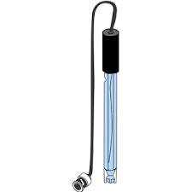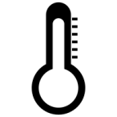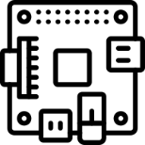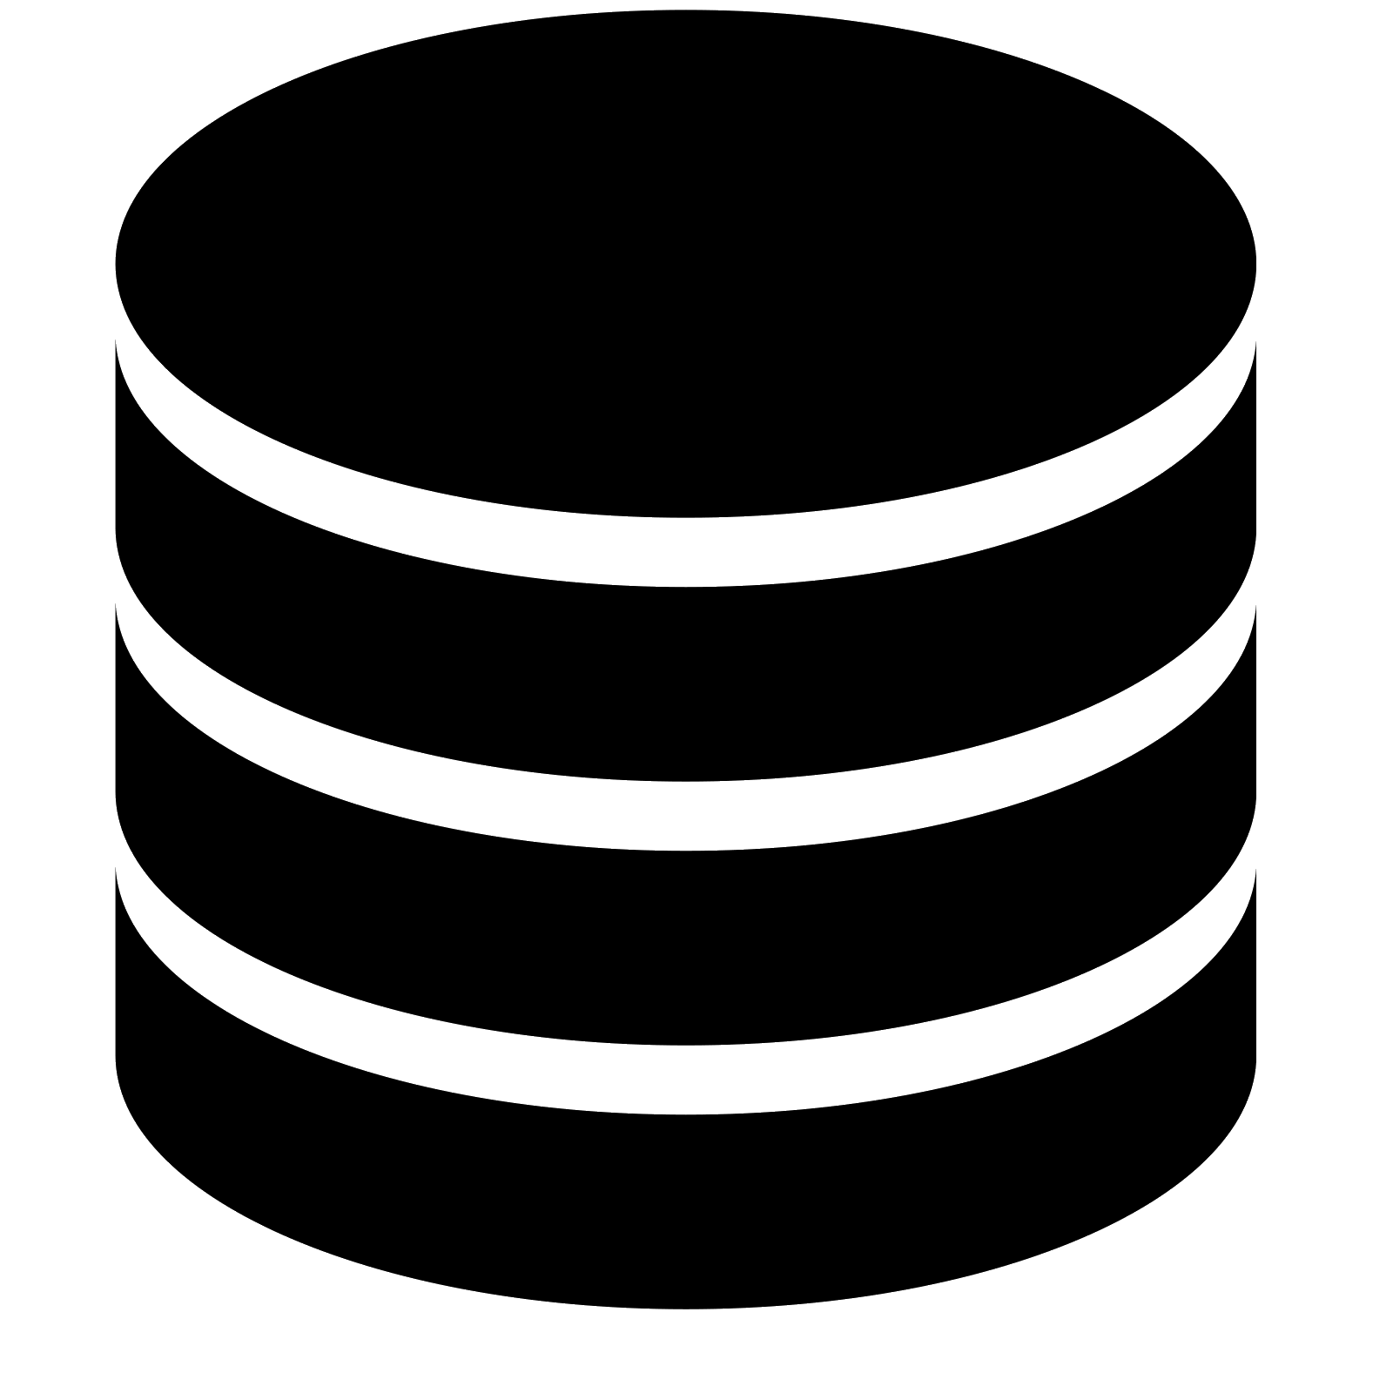

Smartphone

Laptop

Personal

Computer

Raspberry Pi

Temperature Sensor

pH Sensor

Database

Koi Disease Monitoring System

**Figure 12.** *Deployment Diagram*

When the user accesses the system using the website, he/she will be able to manage the system by navigating the website.

*Block Diagram*

Power Supply

SD Card

RASPBERRY PI

Temperature Sensor

pH Sensor

**Figure 13. Block Diagram**

Figure 13 showed the block diagram for the koi disease monitoring system. raspberry pi will be the main component that will be connected with the pH sensor for checking the acidity of the water, temperature sensor for the warmness or coldness of the water, sd card for the operating system (OS) that will be used on the raspberry pi and the power supply that will be used to power the raspberry pi. By using the onboard wireless lan (WLAN) of the raspberry pi, it will be able to connect to the internet.

**Project Evaluation**

In this study the researchers use the ISO/IEC 25010 as the guidelines in evaluating the koi disease monitoring system. This includes the following characteristics:

Functional Suitability. It is the degree to which the set of functions cover all the specified task and user objectives.

Performance Efficiency. It is the degree to which the response and processing times and throughput rates of a product or system, when performing functions, meet requirements.

Efficiency. It is the resources expended in relation to the accuracy and completeness with which users achieve goals.

**Data Gathering Instruments**

The data gathering instruments use is based on ISO/IEC 25010. The checklist is divided into three (3) parts:

The following data scale and description would be used to interpret the data:

For functional suitability of the system:

Scale Interpretation

4.3 - 5.0 Highly Functional

3.5 - 4.2 Very Functional

2.7 - 3.4 Functional

1.9 - 2.6 Slightly Functional

1.0 - 1.8 Not Functional  
For performance efficiency of the system:

Scale Interpretation

4.3 - 5.0 Highly Efficient

3.5 - 4.2 Very Efficient

2.7 - 3.4 Efficient

1.9 - 2.6 Slightly Efficient

1.0 - 1.8 Not Efficient  
For efficiency of the system:

Scale Interpretation

4.3 - 5.0 Highly Efficient

3.5 - 4.2 Very Efficient

2.7 - 3.4 Efficient

1.9 - 2.6 Slightly Efficient

1.0 - 1.8 Not Efficient

**Statistical Data Analysis**

After the evaluation, the responses of the respondents were tallied, analyzed and interpreted with the use of the frequency count and the mean.